

Present Continuous

Fill in the sentences with the verbs in the present continuous and match them to the pictures:

Take, Read, Play (2x), Go, Watch, Walk, Sing, Write, Do, Travel, Speak, Sleep, Run, Ride, Drive, Fly

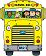
1- Mark _____________________ a bike today.
2- Her father ___________________ a car.
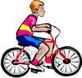
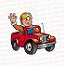
3- I __________________ the bus to school.
4- My friends ____________________ football.
5- Jane ___________________ the piano beautifully.
6- John _________________ his homework quietly.


7- He ________________ French. I don’t understand him.
8- Tom _________________ a letter to a friend.
9- At this moment, Tony __________________ by plane.
10- Lucy ______________________ a colourful kite.
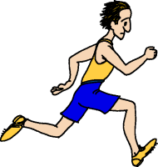

11- Those girls ___________________ a happy song.
12- Thomas ________________ so many books.
13- The fat man __________________ around the town.

14- The athlete __________________ really fast.
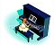
15- The baby ___________________ so peacefully.
16- They ______________________ to the theatre.


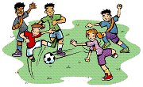
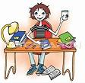
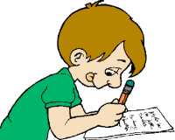
17- They ____________________ a very good film.

